**Practice 1**

Throughout our lessons, we will create a database for some organization. We will collect the data for it, normalize it (divide it into tables). After that the physical data model must be created.

On practical lessons, we'll start first with creating a physical model in Access. We will create tables, connections between them, queries, forms, reports. To do this, you already have a tabled data schema for this subject area.

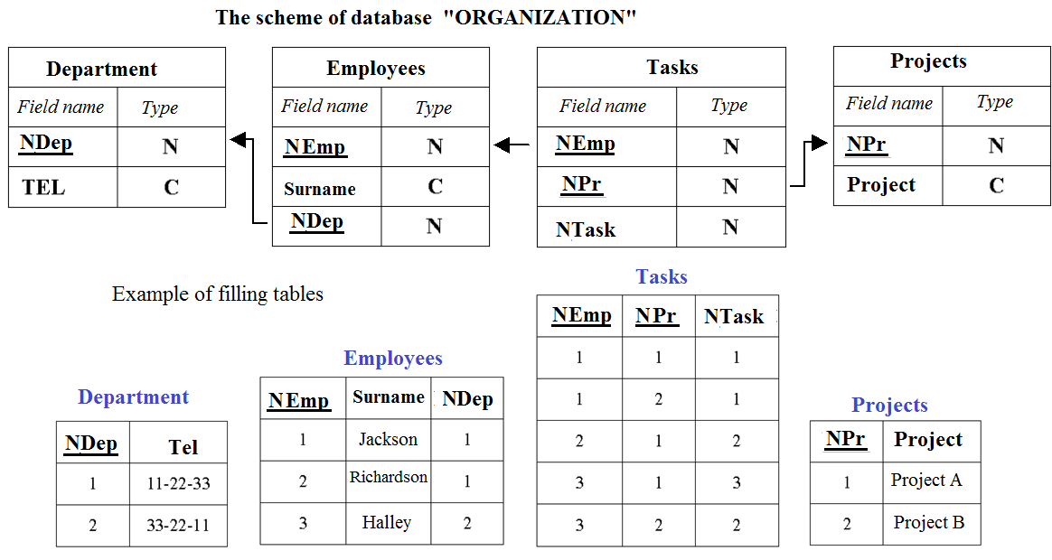

**Task**

**In the Microsoft Access environment**

1.Create new datаbase

2. Go to the ***Tables*** page and create a table structure in ***Design mode***. In the structure of tables, you need to specify the names of the fields and their data type (text or numeric).

3. Assign ***key fields*** in tables. They are underlined in the proposed schema for tables. Key fields must be first in order in the table.

***Key fields*** are table fields by which they are linked to each other.

4. Give names to tables. The default will be Table 1, etc.

5. Fill tables with data. Switch to ***Table mode***. It is necessary to enter 8-10 records (at least) in each table.

In this case, it is necessary to reconcile the data in the key fields. Data in non-key fields can be duplicated.

6. In the ***Data schema tab***, add all created tables and create links between them by key fields.

Links are established with integrity, cascading updates and deletions.

7.Save the created database.